Foundation Stage Curriculum Overview
Blue = 3 – 4 years Development Matters Statements. Black = Reception Development Matters Statements. Green = ELG
Please note that the suggested terms of objectives are flexible and should a child be working above or below age related expectation, they should access the relevant age related learning.
Curriculum Area | Autumn Term |  | Spring Term |  | Summer Term
Term General Theme | Autumn 1 – Traditional tales – 1, 2, 3 | Autumn 2 – Once Upon a Time | Spring 1 – Plants and Growing | Spring 2 – Food, Glorious, Food | Summer 1 – Journeys |  |  | Summer 2 – Animals
Communication and Language | - Enjoy listening to longer stories and can remember much of what happens.  - Pay attention to more than one thing at a time, which can be difficult.  - Use a wider range of vocabulary.  - Understand a question or instruction that has two parts.  - Understand ‘why’ questions.  - Sing a large repertoire of songs.  - Know many rhymes, be able to talk about familiar books, and be able to tell a long story.  - Develop their communication, but may continue to have problems with irregular tenses and plurals  - Develop their pronunciation but may have problems saying: - some sounds: r, j, th, ch, and sh - multi-syllabic words  - Use longer sentences of four to six words  - Be able to express a point of view and to debate when they disagree with an adult or a friend, using words as well as actions.  - Start a conversation with an adult or a friend and continue it for many turns.  - Use talk to organise themselves and their play. | - Understand how to listen carefully and why listening is important.  - Learn new vocabulary.  - Use new vocabulary through the day.  - Ask questions to find out more and to check they understand what has been said to them.  - Articulate their ideas and thoughts in well-formed sentences.  - Connect one idea or action to another using a range of connectives.  - Describe events in some detail.  - Use talk to help work out problems and organise thinking and activities, and to explain how things work and why they might happen.  - Develop social phrases.  - Engage in storytimes  - Listen to and talk about stories to build familiarity and understanding.  - Retell the story, once they have developed a deep familiarity with the text; some as exact repetition and some in their own words.  - Use new vocabulary in different contexts.  - Listen carefully to rhymes and songs, paying attention to how they sound.  - Learn rhymes, poems and songs.  - Engage in non-fiction books.  - Listen to and talk about selected non-fiction to develop a deep familiarity with new knowledge and vocabulary. | - Understand how to listen carefully and why listening is important.  - Learn new vocabulary.  - Use new vocabulary through the day.  - Ask questions to find out more and to check they understand what has been said to them.  - Articulate their ideas and thoughts in well-formed sentences.  - Connect one idea or action to another using a range of connectives.  - Describe events in some detail.  - Use talk to help work out problems and organise thinking and activities, and to explain how things work and why they might happen.  - Develop social phrases.  - Engage in storytimes  - Listen to and talk about stories to build familiarity and understanding.  - Retell the story, once they have developed a deep familiarity with the text; some as exact repetition and some in their own words.  - Use new vocabulary in different contexts.  - Listen carefully to rhymes and songs, paying attention to how they sound.  - Learn rhymes, poems and songs.  - Engage in non-fiction books.  - Listen to and talk about selected non-fiction to develop a deep familiarity with new knowledge and vocabulary. | - Understand how to listen carefully and why listening is important.  - Learn new vocabulary.  - Use new vocabulary through the day.  - Ask questions to find out more and to check they understand what has been said to them.  - Articulate their ideas and thoughts in well-formed sentences.  - Connect one idea or action to another using a range of connectives.  - Describe events in some detail.  - Use talk to help work out problems and organise thinking and activities, and to explain how things work and why they might happen.  - Develop social phrases.  - Engage in storytimes  - Listen to and talk about stories to build familiarity and understanding.  - Retell the story, once they have developed a deep familiarity with the text; some as exact repetition and some in their own words.  - Use new vocabulary in different contexts.  - Listen carefully to rhymes and songs, paying attention to how they sound.  - Learn rhymes, poems and songs.  - Engage in non-fiction books.  - Listen to and talk about selected non-fiction to develop a deep familiarity with new knowledge and vocabulary. | Listening, Attention and Understanding ELG  - Listen attentively and respond to what they hear with relevant questions, comments and actions when being read to and during whole class discussions and small group interactions  - Make comments about what they have heard and ask questions to clarify their understanding  - Hold conversation when engaged in back-and-forth exchanges with their teacher and peers.  Speaking ELG  - Participate in small group, class and one-to-one discussions, offering their own ideas, using recently introduced vocabulary  - Offer explanations for why things might happen, making use of recently introduced vocabulary from stories, non-fiction, rhymes and poems when appropriate  - Express their ideas and feelings about their experiences using full sentences, including use of past, present and future tenses and making use of conjunctions, with modelling and support from their teacher. |  |  | Listening, Attention and Understanding ELG  - Listen attentively and respond to what they hear with relevant questions, comments and actions when being read to and during whole class discussions and small group interactions  - Make comments about what they have heard and ask questions to clarify their understanding  - Hold conversation when engaged in back-and-forth exchanges with their teacher and peers.  Speaking ELG  - Participate in small group, class and one-to-one discussions, offering their own ideas, using recently introduced vocabulary  - Offer explanations for why things might happen, making use of recently introduced vocabulary from stories, non-fiction, rhymes and poems when appropriate  - Express their ideas and feelings about their experiences using full sentences, including use of past, present and future tenses and making use of conjunctions, with modelling and support from their teacher.
C & L Skills  Speaking skills | - To understand how to listen carefully  - To understand why listening is important  - To be able to follow directions  - To talk in front of a small group  - To talk to class to adults in the class  - To learn new vocabulary  - To engage in story times, joining in with repeated phrases and actions  - To begin to understand how and why questions  - To respond to instructions with more than one step |  | - To ask questions to find out more  - To begin to understand humour  - To understand a range of complex sentence structures  - To retell a story to follow a story without pictures or props  - To develop the confidence to talk to other adults they see on a daily basis  - To talk in sentences using conjunctions e.g. and, because  - To use new vocabulary in different contexts to engage in non-fiction books |  | - To understand questions such as who, what, where, when, why and how  - To have conversations with adults and peers with back and forth exchanges  - To link statements and stick to a main theme  - To use talk to organise, sequence and clarify thinking, ideas, feelings and events  - To talk about why things, happen to talk in sentences using a range of tenses  - To talk to different adults around the school
Personal Social and Emotional Development | - Select and use activities and resources, with help when needed. This helps them to achieve a goal they have chosen, or one which is suggested to them.  - Develop their sense of responsibility and membership of a community.  - Become more outgoing with unfamiliar people, in the safe context of their setting.  - Show more confidence in new social situations.  - Play with one or more other children, extending and elaborating play ideas.  - Find solutions to conflicts and rivalries  - Increasingly follow rules, understanding why they are important.  - Remember rules without needing an adult to remind them  - Develop appropriate ways of being assertive.  - Talk with others to solve conflicts.  - Talk about their feelings using words like ‘happy’, ‘sad’, ‘angry’ or ‘worried’.  - Understand gradually how others might be feeling | - See themselves as a valuable individual.  - Build constructive and respectful relationships.  - Express their feelings and consider the feelings of others.  - Show resilience and perseverance in the face of challenge.  - Identify and moderate their own feelings socially and emotionally.  - Think about the perspectives of others.  - Manage their own needs. | - See themselves as a valuable individual.  - Build constructive and respectful relationships.  - Express their feelings and consider the feelings of others.  - Show resilience and perseverance in the face of challenge.  - Identify and moderate their own feelings socially and emotionally.  - Think about the perspectives of others.  - Manage their own needs. | - See themselves as a valuable individual.  - Build constructive and respectful relationships.  - Express their feelings and consider the feelings of others.  - Show resilience and perseverance in the face of challenge.  - Identify and moderate their own feelings socially and emotionally.  - Think about the perspectives of others.  - Manage their own needs. | Self-Regulation  - Show an understanding of their own feelings and those of others, and begin to regulate their behaviour accordingly  - Set and work towards simple goals, being able to wait for what they want and control their immediate impulses when appropriate  - Give focused attention to what the teacher says, responding appropriately even when engaged in activity, and show an ability to follow instructions involving several ideas or actions.  Managing Self  - Be confident to try new activities and show independence, resilience and  perseverance in the face of challenge  - Explain the reasons for rules, know right from wrong and try to behave accordingly  - Manage their own basic hygiene and personal needs, including dressing, going to the toilet and understanding the importance of healthy food choices.  Building Relationships  - Work and play cooperatively and take turns with others  - Form positive attachments to adults and friendships with peers  - Show sensitivity to their own and to others’ needs. |  |  | Self-Regulation  - Show an understanding of their own feelings and those of others, and begin to regulate their behaviour accordingly  - Set and work towards simple goals, being able to wait for what they want and control their immediate impulses when appropriate  - Give focused attention to what the teacher says, responding appropriately even when engaged in activity, and show an ability to follow instructions involving several ideas or actions.  Managing Self  - Be confident to try new activities and show independence, resilience and  perseverance in the face of challenge  - Explain the reasons for rules, know right from wrong and try to behave accordingly  - Manage their own basic hygiene and personal needs, including dressing, going to the toilet and understanding the importance of healthy food choices.  Building Relationships  - Work and play cooperatively and take turns with others  - Form positive attachments to adults and friendships with peers  Show sensitivity to their own and to others’ needs.
Self – help Skills Progression  *cutlery skills to be developed in shared area using cutlery and playdough/ dolls heads and pompoms/ large teeth set and spoons | - Holds fork correctly in preferred hand and is able to ‘stab’ food for eating  - Use a spoon for dessert  - Adult support for cutting of food  - To put coat and shoes on independently  - Get changed for P.E. with support | - Holds fork correctly to begin to cut soft food  - Uses knife with hand over hand for cutting of food that is more difficult.  - Uses a spoon for dessert  - Put coat on by self and ‘zip this up’ independently  - Get dressed for P.E without support | - Uses a knife and fork to cut an increasing range of foods with varying textures and density.  - Increasing accuracy when eating food  - To practise doing buttons | - Uses cutlery with increasing accuracy with minimal support for cutting and food spillages decreasing  - majority of buttons can be done up by self |  | - Uses cutlery independently and accurately. With minimal food spillage  - Dresses and undresses for P.E without support manipulating clothes fastenings to open and close these independently.
Physical Development | - Continue to develop their movement, balancing, riding and ball skills.  - Go up steps and stairs, or climb up apparatus, using alternate feet.  - Skip, hop, stand on one leg and hold a pose for a game like musical statues.  - Use large-muscle movements to wave flags and streamers, paint and make marks  - Start taking part in some group activities which they make up for themselves, or in teams.  - Increasingly be able to use and remember sequences and patterns of movements which are related to music and rhythm.  - Match their developing physical skills to tasks and activities in the setting. For example, they decide whether to crawl, walk or run across a plank, depending on its length and width.  - Choose the right resources to carry out their own plan.  - Collaborate with others to manage large items, such as moving a long plank safely, carrying large hollow blocks.  - Use one-handed tools and equipment.  - Use a comfortable grip with good control when holding pens and pencils.  - Start eating independently and learning how to use a knife and fork.  - Show a preference for a dominant hand.  - Be increasingly independent as they get dressed and undressed.  - Be increasingly independent in meeting their own care needs, e.g. brushing teeth, using the toilet, washing and drying their hands thoroughly.  - Make healthy choices about food, drink, activity and toothbrushing. | - Revise and refine the fundamental movement skills they have already acquired:  - rolling  - crawling  - walking  - jumping  - running  - hopping  - skipping  - climbing  - Progress towards a more fluent style of moving, with developing control and grace.  - Develop the overall body strength, co-ordination, balance and agility needed to engage successfully with future physical education sessions and other physical disciplines.  - Develop their small motor skills so that they can use a range of tools competently, safely and confidently. Suggested tools: pencils for drawing and writing, paintbrushes, scissors, knives, forks and spoons.  - Use their core muscle strength to achieve a good posture when sitting at a table or sitting on the floor  - Combine different movements with ease and fluency.  - Confidently and safely use a range of large and small apparatus indoors and outside, alone and in a group.  - Develop overall body-strength, balance, co-ordination and agility.  - Further develop and refine a range of ball skills including: throwing, catching, kicking, passing, batting, and aiming. Develop confidence, competence, precision and accuracy when engaging in activities that involve a ball.  - Develop the foundations of a handwriting style which is fast, accurate and efficient.  - Know and talk about the different factors that support their overall health and wellbeing:  - regular physical activity  - healthy eating  - toothbrushing  - sensible amounts of ‘screen time’  - having a good sleep routine  - being a safe pedestrian  - Further develop the skills they need to manage the school day successfully:  - lining up and queuing  - mealtimes  - personal hygiene | - Revise and refine the fundamental movement skills they have already acquired:  - rolling  - crawling  - walking  - jumping  - running  - hopping  - skipping  - climbing  - Progress towards a more fluent style of moving, with developing control and grace.  - Develop the overall body strength, co-ordination, balance and agility needed to engage successfully with future physical education sessions and other physical disciplines.  - Develop their small motor skills so that they can use a range of tools competently, safely and confidently. Suggested tools: pencils for drawing and writing, paintbrushes, scissors, knives, forks and spoons.  - Use their core muscle strength to achieve a good posture when sitting at a table or sitting on the floor  - Combine different movements with ease and fluency.  - Confidently and safely use a range of large and small apparatus indoors and outside, alone and in a group.  - Develop overall body-strength, balance, co-ordination and agility.  - Further develop and refine a range of ball skills including: throwing, catching, kicking, passing, batting, and aiming. Develop confidence, competence, precision and accuracy when engaging in activities that involve a ball.  - Develop the foundations of a handwriting style which is fast, accurate and efficient.  - Know and talk about the different factors that support their overall health and wellbeing:  - regular physical activity  - healthy eating  - toothbrushing  - sensible amounts of ‘screen time’  - having a good sleep routine  - being a safe pedestrian  - Further develop the skills they need to manage the school day successfully:  - lining up and queuing  - mealtimes  - personal hygiene | - Revise and refine the fundamental movement skills they have already acquired:  - rolling  - crawling  - walking  - jumping  - running  - hopping  - skipping  - climbing  - Progress towards a more fluent style of moving, with developing control and grace.  - Develop the overall body strength, co-ordination, balance and agility needed to engage successfully with future physical education sessions and other physical disciplines.  - Develop their small motor skills so that they can use a range of tools competently, safely and confidently. Suggested tools: pencils for drawing and writing, paintbrushes, scissors, knives, forks and spoons.  - Use their core muscle strength to achieve a good posture when sitting at a table or sitting on the floor  - Combine different movements with ease and fluency.  - Confidently and safely use a range of large and small apparatus indoors and outside, alone and in a group.  - Develop overall body-strength, balance, co-ordination and agility.  - Further develop and refine a range of ball skills including: throwing, catching, kicking, passing, batting, and aiming. Develop confidence, competence, precision and accuracy when engaging in activities that involve a ball.  - Develop the foundations of a handwriting style which is fast, accurate and efficient.  - Know and talk about the different factors that support their overall health and wellbeing:  - regular physical activity  - healthy eating  - toothbrushing  - sensible amounts of ‘screen time’  - having a good sleep routine  - being a safe pedestrian  - Further develop the skills they need to manage the school day successfully:  - lining up and queuing  - mealtimes  - personal hygiene | Gross Motor Skills  - Negotiate space and obstacles safely, with consideration for themselves and others  - Demonstrate strength, balance and coordination when playing  - Move energetically, such as running, jumping, dancing, hopping, skipping and climbing.  Fine Motor Skills  - Hold a pencil effectively in preparation for fluent writing – using the tripod grip in almost all cases  - Use a range of small tools, including scissors, paint brushes and cutlery  - Begin to show accuracy and care when drawing. |  |  | Gross Motor Skills  - Negotiate space and obstacles safely, with consideration for themselves and others  - Demonstrate strength, balance and coordination when playing  - Move energetically, such as running, jumping, dancing, hopping, skipping and climbing.  Fine Motor Skills  - Hold a pencil effectively in preparation for fluent writing – using the tripod grip in almost all cases  - Use a range of small tools, including scissors, paint brushes and cutlery  - Begin to show accuracy and care when drawing.
Scissor Skills Progression  (taken from)  https://www.growinghandsonkids.com/scissor-skill-development-checklist-for-ages-2-6.html  https://www.theottoolbox.com/steps-of-scissor-skill-development/ | - Snip paper moving forward (tearing paper may be seen) | - Snip paper moving forward without tearing paper  - cut straight lines forward across a page, while moving the helper hand forward (moving the paper with the scissors as in raising the shoulders or extending the elbows)  - Cut in straight line ½ inch close to a cutting line | - Cut in straight line ¼ inch close to a cutting line  - Child is able to cut straight lines forward without experiencing forward movement of the helper hand  - Cut on a curved line progress to circles  - Child is able to cut simple curves and angled lines (one direction change) without moving the assisting hand on the paper to re-position | - Cut out a square shape within ¼ inch of cutting line  - Child is able to cut simple curves and angled lines (one direction change) while moving the assisting hand on the paper to re-position | - Cuts out more complex shapes
PE BEING TAUGHT | - Big Moves & Spatial Awareness Games | - Gymnastics | - Dance | - Ball Skills | - Athletics and Races  (Running, Jumping and Throwing) |  | - Team Games
Focus Books | - Goldilocks and the Three Bears  - Three Little Pigs  - Three Billy Goats Gruff | - Brown Bear, Brown Bear What do you see?  - Owl Babies  - The Gingerbread Man  - The Gruffalo  - Polar Bear, Polar Bear What Do You Hear?  - The Nativity Story | - Titch  - Sam Plants a Sunflower  - Jasper’s Beanstalk  - Jack and the Beanstalk  - The Enormous Turnip | - Handa’s Surprise  - Oliver’s Fruit Salad  - Supertato  - The Tiger who Came to Tea  - Supermarket Zoo  - Pass the Jam Jim | - The Train Ride  - We’re Going on a Bear Hunt  - How to Catch a Star  - Pirates Love Underpants  - The Bad-Tempered Ladybird  - Tadpole’s Promise  - The Hungry Caterpillar |  | - Cock a Moo Moo  - Monkey Puzzle  - Rainbow Fish  - If Sharks Disappeared  - Harry and His Bucket of Dinosaurs  - Tyrannosaurs Drip
Literacy - Comprehension | - Understand the five key concepts about print:  - print has meaning  - print can have different purposes  - we read English text from left to right and from top to bottom  - the names of the different parts of a book  - page sequencing  - Engage in extended conversations about stories, learning new vocabulary. | - Re-read these books to build up their confidence in word reading, their fluency and their understanding and enjoyment. | - Re-read these books to build up their confidence in word reading, their fluency and their understanding and enjoyment. | - Re-read these books to build up their confidence in word reading, their fluency and their understanding and enjoyment. | - Demonstrate understanding of what has been read to them by retelling stories and narratives using their own words and recently introduced vocabulary  - Anticipate – where appropriate – key events in stories  - Use and understand recently introduced vocabulary during discussions about stories, non-fiction, rhymes and poems and during role-play. |  |  | - Demonstrate understanding of what has been read to them by retelling stories and narratives using their own words and recently introduced vocabulary  - Anticipate – where appropriate – key events in stories  - Use and understand recently introduced vocabulary during discussions about stories, non-fiction, rhymes and poems and during role-play.
Comprehension skills progression | - To use pictures to tell stories  - To sequence familiar stories  - To independently look at book, holding them the correct way and turning pages | - To engage in story times, joining in with repeated phrases and actions  - To begin to answer questions about the stories read to them  - To enjoy and increasing range of books including fiction, non-fiction, poems and rhymes | - To act out stories  - To begin to predict what may happen in the story  - To suggest how a story might end | - To retell a story  - To follow a story without pictures or props  - To talk about the characters in the books they are reading | - To begin to answer questions about what they have read  - To use vocabulary that is influenced by their experiences of books |  |  | - To answer questions about what they have read  - To know that information can be retrieved from books
Literacy – word reading | - Develop their phonological awareness, so that they can:  - spot and suggest rhymes  - count or clap syllables in a word  - recognise words with the same initial sound | - Read individual letters by saying the sounds for them.  - Blend sounds into words, so that they can read short words made up of known letter– sound correspondences.  - Read some letter groups that each represent one sound and say sounds for them.  - Read a few common exception words matched to the school’s phonic programme.  - Read simple phrases and sentences made up of words with known letter–sound correspondences and, where necessary, a few exception words.  - Recognise the digraphs ss, ff, ll. Ck, | - Read individual letters by saying the sounds for them.  - Blend sounds into words, so that they can read short words made up of known letter– sound correspondences.  - Read some letter groups that each represent one sound and say sounds for them.  - Read a few common exception words matched to the school’s phonic programme.  - Read simple phrases and sentences made up of words with known letter–sound correspondences and, where necessary, a few exception words  - Recognise the digraphs zz, qu, ch, sh, ng, th, ai, ee, oo, oa. | - Read individual letters by saying the sounds for them.  - Blend sounds into words, so that they can read short words made up of known letter– sound correspondences.  - Read some letter groups that each represent one sound and say sounds for them.  - Read a few common exception words matched to the school’s phonic programme.  - Read simple phrases and sentences made up of words with known letter–sound correspondences and, where necessary, a few exception words  - Recognise the digraphs oi, ar, ur, or, er, ow  - Recognise the trigraphs igh, air, ear, ure | - Say a sound for each letter in the alphabet and at least 10 digraphs  - Read words consistent with their phonic knowledge by sound-blending  - Read aloud simple sentences and books that are consistent with their phonic knowledge, including some common exception words. |  |  | - Say a sound for each letter in the alphabet and at least 10 digraphs  - Read words consistent with their phonic knowledge by sound-blending  - Read aloud simple sentences and books that are consistent with their phonic knowledge, including some common exception words.
Literacy - Writing | - Use some of their print and letter knowledge in their early writing.  - Write some or all of their name.  - Write some letters accurately | - Spell words by identifying the sounds and then writing the sound with letter/s.  - Write short sentences with words with known sound-letter correspondences using a capital letter and full stop.  - Re-read what they have written to check that it makes sense. | - Spell words by identifying the sounds and then writing the sound with letter/s.  - Write short sentences with words with known sound-letter correspondences using a capital letter and full stop.  - Re-read what they have written to check that it makes sense. | - Form lower-case and capital letters correctly.  - Spell words by identifying the sounds and then writing the sound with letter/s.  - Write short sentences with words with known sound-letter correspondences using a capital letter and full stop.  - Re-read what they have written to check that it makes sense. | - Write recognisable letters, most of which are correctly formed  - Spell words by identifying sounds in them and representing the sounds with a letter or letters  - Write simple phrases and sentences that can be read by others. |  |  | - Write recognisable letters, most of which are correctly formed  - Spell words by identifying sounds in them and representing the sounds with a letter or letters  Write simple phrases and sentences that can be read by others.
Phonics | - Phase 1 &2 | - Phase 2 | - Phase 3 | - Phase 3 & bespoke phonics | - Phase 4 |  |  | Bespoke individual to class needs
Handwriting Skills progression | - Develop comfortable and correct pencil grip  - Forms letters of name correctly with or without name card  - Can from a circle  - Draw a straight horizontal line  - Draw a straight vertical line  - Create zig zag line | - Write own name with letters formed correctly.  - Form with increasing accuracy:  c, a, d, o, s, g, e, f  - Form with increasing accuracy:  l, i, t  - Form with increasing accuracy:  r, b, n, h, m, k, p  - Begin to form phase 2 sounds in capitals | - Correctly form:  c, a, d, o, s, g, e, f  l, i, t  r, b, n, h, m, k, p  - Begin to form phase 3 sounds in capitals (J V W X Y Z Q) | - Correctly form  l, i, t, u, j, y  r, b, n, h, m, k, p  c, a, d, o, s, g, q, e, f  z, v, w, x | - Correct formation of capital letters  - All lowercase letters are formed correctly in readiness for joined up hand writing
Mathematics -Number | - Know that the last number reached when counting a small set of objects tells you how many there are in total  - Show ‘finger numbers’ up to 5  - Link numerals and amounts, up to 5  - Experiment with their own symbols and marks as well as numerals.  - Solve real world mathematical problems with numbers up to 5 | - Count objects, actions and sounds.  - Subitise.  - Link the number symbol (numeral) with its cardinal number value  - Count beyond ten.  - Explore the composition of numbers to 10. | - Count objects, actions and sounds.  - Subitise.  - Link the number symbol (numeral) with its cardinal number value  - Count beyond ten.  - Explore the composition of numbers to 10. | - Count objects, actions and sounds.  - Subitise.  - Link the number symbol (numeral) with its cardinal number value  - Count beyond ten.  - Explore the composition of numbers to 10. | - Have a deep understanding of number to 10, including the composition of each number  - Subitise (recognise quantities without counting) up to 5  - Automatically recall (without reference to rhymes, counting or other aids) number bonds up to 5 (including subtraction facts) and some number bonds to 10, including double facts. |  |  | - Have a deep understanding of number to 10, including the composition of each number  - Subitise (recognise quantities without counting) up to 5  - Automatically recall (without reference to rhymes, counting or other aids) number bonds up to 5 (including subtraction facts) and some number bonds to 10, including double facts.
Maths Skills Progression | - To recognise numbers 1-3  - To begin to subitise to 3  - To find one more of numbers to 3  - To find one less of numbers to 3  - To explore the composition of 2 and 3 | - To recognise numbers 1-5 To begin to subitise to 5  - To find one more of numbers to 5  - To find one less of numbers to 5  - To explore the composition of 4 and 5 | - To recognise numbers 0-8  - To subitise to 5  - To find one more of numbers to 8  - To find one less of numbers to 8  - To explore the composition of 6, 7 and 8  - To match the number to quantity | - To recognise numbers 0-10  - To explore the composition of 9 and 10  - To practise number bonds to 10  - To know addition facts to make 5  - To find one more of numbers to 10  - To find one less of numbers to 10  - To estimate a number of objects | - To recognise numbers to 20  - To revise number bonds to 5  - To explore how to make numbers above ten using tens and ones  - To match the number to quantity |  |  | - To solve simple number problems  - To recap the composition of each number to 10  - To know addition and subtraction facts to 10  - To know doubling facts
Mathematics – Numerical Patterns | - Compare quantities using language: ‘more than’, ‘fewer than’.  - Talk about and explore 2D and 3D shapes (for example, circles, rectangles, triangles and cuboids) using informal and mathematical language: ‘sides’, ‘corners’; ‘straight’, ‘flat’, ‘round’.  - Understand position through words alone  - Describe a familiar route.  - Discuss routes and locations, using words like ‘in front of’ and ‘behind’.  - Make comparisons between objects relating to size, length, weight and capacity.  - Select shapes appropriately: flat surfaces for building, a triangular prism for a roof etc.  - Combine shapes to make new ones - an arch, a bigger triangle etc.  - Talk about and identify the patterns around them.  - Extend and create ABAB patterns – stick, leaf, stick, leaf.  - Notice and correct an error in a repeating pattern.  - Begin to describe a sequence of events, real or fictional, using words such as ‘first’, ‘then’ | - Compare numbers.  - Understand the ‘one more than/one less than’ relationship between consecutive numbers.  - Automatically recall number bonds for numbers 0–10.  - Select, rotate and manipulate shapes in order to develop spatial reasoning skills.  - Compose and decompose shapes so that children recognise a shape can have other shapes within it, just as numbers can.  - Continue, copy and create repeating patterns.  - Compare length, weight and capacity | - Compare numbers.  - Understand the ‘one more than/one less than’ relationship between consecutive numbers.  - Automatically recall number bonds for numbers 0–10.  - Select, rotate and manipulate shapes in order to develop spatial reasoning skills.  - Compose and decompose shapes so that children recognise a shape can have other shapes within it, just as numbers can.  - Continue, copy and create repeating patterns.  - Compare length, weight and capacity | - Compare numbers.  - Understand the ‘one more than/one less than’ relationship between consecutive numbers.  - Automatically recall number bonds for numbers 0–10.  - Select, rotate and manipulate shapes in order to develop spatial reasoning skills.  - Compose and decompose shapes so that children recognise a shape can have other shapes within it, just as numbers can.  - Continue, copy and create repeating patterns.  - Compare length, weight and capacity | - Verbally count beyond 20, recognising the pattern of the counting system  - Compare quantities up to 10 in different contexts, recognising when one quantity is greater than, less than or the same as the other quantity  - Explore and represent patterns within numbers up to 10, including evens and odds, double facts and how quantities can be distributed equally. |  |  | - Verbally count beyond 20, recognising the pattern of the counting system  - Compare quantities up to 10 in different contexts, recognising when one quantity is greater than, less than or the same as the other quantity  - Explore and represent patterns within numbers up to 10, including evens and odds, double facts and how quantities can be distributed equally.
Numerical patterns – Skills progression | - To say which group has more  - To say which group has less  - To compare quantities to 3  - To count to 5 | - To compare quantities to 5  - To compare equal and unequal groups  - To count to 10 | - To count to 10 To count objects to 10  - To compare quantities to 8  - To combine two groups of objects | - To compare quantities to 10  - To explore odd and even numbers  - To order numbers to 10  - To count back from 10  - To combine two groups of objects  - To take away objects and count how many are left | - To count to 15  - To add numbers  - To subtract numbers  - To find the missing number  - To order numbers to 20  - To order numbers e.g. 13, 15, 19  - To find the missing number in an addition and subtraction sentence problems |  |  | - To count to 20 and beginning to count higher  - To know that 1, 3, 5, 7 and 9 are odd  - To know that 2, 4, 6, 8, 10 are even  - To double numbers up to 10  - To find half of numbers up to 10  - To share quantities equally
White Rose Maths being taught | - Match and sort  - Compare amounts  - Representing 1, 2 ,3  - Comparing 1 ,2 ,3  - Composition of 1, 2 ,3  - Representing numbers to 5  - One more one less |  | - Introducing 0  - Comparing numbers to 5  - Composition of 4 and 5  - 6, 7, 8  - Making pairs  - Combining groups  - 9 and 10  - Comparing numbers to 10  - Bonds to 10 |  | - Building numbers beyond 10  - Counting patterns beyond 10  - Adding more  - Taking away  - Doubling  - Sharing and grouping  - Even and odd
Shape, Space and Measure aspects covered | - Comparing size, mass and capacity  - Exploring pattern  - common 2D shapes (circle, triangle, square, rectangle)  - Positional language  - Time |  | - Comparing mass  - Length  - Height  - Time  - 3D shape |  | - Spatial reasoning: match, rotate manipulate  - Spatial reasoning: compose and decompose  - Spatial reasoning: Visualise and build  - Spatial reasoning mapping
Understanding the World | - Use all their senses in hands on exploration of natural materials.  - Explore collections of materials with similar and/or different properties.  - Talk about what they see, using a wide vocabulary  - Begin to make sense of their own life-story and family’s history.  - Show interest in different occupations.  - Explore how things work.  - Plant seeds and care for growing plants  - Understand the key features of the life cycle of a plant and an animal.  - Begin to understand the need to respect and care for the natural environment and all living things  - Explore and talk about different forces they can feel.  - Talk about the differences between materials and changes they notice.  - Continue developing positive attitudes about the differences between people.  - Know that there are different countries in the world and talk about the differences they have experienced or seen in photos. | - Talk about members of their immediate family and community.  - Name and describe people who are familiar to them.  - Comment on images of familiar situations in the past.  - Compare and contrast characters from stories, including figures from the past.  - Draw information from a simple map.  - Understand that some places are special to members of their community.  - Recognise that people have different beliefs and celebrate special times in different ways  - Recognise some similarities and differences between life in this country and life in other countries.  - Explore the natural world around them.  - Describe what they see, hear and feel whilst outside.  - Recognise some environments that are different to the one in which they live.  - Understand the effect of changing seasons on the natural world around them. | - Talk about members of their immediate family and community.  - Name and describe people who are familiar to them.  - Comment on images of familiar situations in the past.  - Compare and contrast characters from stories, including figures from the past.  - Draw information from a simple map.  - Understand that some places are special to members of their community.  - Recognise that people have different beliefs and celebrate special times in different ways  - Recognise some similarities and differences between life in this country and life in other countries.  - Explore the natural world around them.  - Describe what they see, hear and feel whilst outside.  - Recognise some environments that are different to the one in which they live.  - Understand the effect of changing seasons on the natural world around them. | - Talk about members of their immediate family and community.  - Name and describe people who are familiar to them.  - Comment on images of familiar situations in the past.  - Compare and contrast characters from stories, including figures from the past.  - Draw information from a simple map.  - Understand that some places are special to members of their community.  - Recognise that people have different beliefs and celebrate special times in different ways  - Recognise some similarities and differences between life in this country and life in other countries.  - Explore the natural world around them.  - Describe what they see, hear and feel whilst outside.  - Recognise some environments that are different to the one in which they live.  - Understand the effect of changing seasons on the natural world around them. | Past and Present  - Talk about the lives of the people around them and their roles in society  - Know some similarities and differences between things in the past and now, drawing on their experiences and what has been read in class  - Understand the past through settings, characters and events encountered in books read in class and storytelling  People Culture and Communities  - Describe their immediate environment using knowledge from observation, discussion, stories, non-fiction texts and maps  - Know some similarities and differences between different religious and cultural communities in this country, drawing on their experiences and what has been read in class  - Explain some similarities and differences between life in this country and life in other countries, drawing on knowledge from stories, non-fiction texts and – when appropriate – maps.  The Natural World  - Explore the natural world around them, making observations and drawing pictures of animals and plants  - Know some similarities and differences between the natural world around them and contrasting environments, drawing on their experiences and what has been read in class  - Understand some important processes and changes in the natural world around them, including the seasons and changing states of matter. |  |  | Past and Present  - Talk about the lives of the people around them and their roles in society  - Know some similarities and differences between things in the past and now, drawing on their experiences and what has been read in class  - Understand the past through settings, characters and events encountered in books read in class and storytelling  People Culture and Communities  - Describe their immediate environment using knowledge from observation, discussion, stories, non-fiction texts and maps  - Know some similarities and differences between different religious and cultural communities in this country, drawing on their experiences  and what has been read in class  - Explain some similarities and differences between life in this country and life in other countries, drawing on knowledge from stories, non-fiction texts and – when appropriate – maps.  The Natural World  - Explore the natural world around them, making observations and drawing pictures of animals and plants  - Know some similarities and differences between the natural world around them and contrasting environments, drawing on their experiences and what has been read in class  Understand some important processes and changes in the natural world around them, including the seasons and changing states of matter.
Past and present Skills progression | - To know about my own life-story  - To know how I have changed | - To know about figures from the past  - To know some similarities and differences between things in the past and now, drawing on experiences and what has been read in class | - To talk about the lives of the people around us.  - To know that the emergency services exist and what they do.  - To know some similarities and differences between things in the past and now, drawing on experiences and what has been read in class | - To know about the past through settings, characters and events encountered in books read in class and storytelling | - To know about the past through settings, characters and events encountered in books read in class and story telling |  |  | - To know some similarities and differences between things in the past and now, drawing on experiences and what has been read in class
People Culture and Communities skills progression | - To know about family structures and talk about who is part of their family  - To identify similarities and differences between themselves and peers.  - To know about features of the immediate environment.  - To know that there are many countries around the world. | - To talk about how Hindus, celebrate Diwali  - To talk about the Christmas Story and how it is celebrated  - To know that people around the world have different religions  - Eid to be taught when this falls | - To talk about Chinese New Year.  - To know about people who help us within the local community  - Eid to be taught when this falls | - To know that Christians celebrate Easter. | - To know that people in other countries may speak different languages |  |  | - To know that people in other countries may speak different languages  - To know that simple symbols are used to identify features on a map
The Natural world Skills progression | - To ask questions about the natural environment.  - To respect and care for the natural environments | - To know about and recognise the signs of Autumn  - To know about features of the world and Earth | - To know about and recognise the signs of Winter  - To know some important processes and changes in the natural world including states of matter (freezing) | - To know about and recognise the signs of Spring  - To know about features of my own immediate environment and how they might vary from another.  - To plant seeds | - To know the difference between herbivores and carnivores  - To observe the growth of seeds and talk about changes  - To know how to care for growing plants  - To learn about lifecycles of plants and animals  - To know that some animals are nocturnal  - To know about different habitats |  |  | - To know about and recognise the signs of Summer  - To know that some things in the world are man-made and some things are natural  - To know some important processes and changes in the natural world including states of matter (melting, floating and sinking)
Expressive Art and Design | - Take part in simple pretend play, using an object to represent something else even though they are not similar.  - Begin to develop complex stories using small world equipment like animal sets, dolls and dolls houses etc.  - Make imaginative and complex ‘small worlds’ with blocks and construction kits, such as a city with different buildings and a park.  - Explore different materials freely, in order to develop their ideas about how to use them and what to make.  - Develop their own ideas and then decide which materials to use to express them.  - Join different materials and explore different textures.  - Create closed shapes with continuous lines, and begin to use these shapes to represent objects.  - Draw with increasing complexity and detail, such as representing a face with a circle and including details.  - Use drawing to represent ideas like movement or loud noises.  - Show different emotions in their drawings and paintings, like happiness, sadness, fear etc.  - Explore colour and colour mixing.  - Listen with increased attention to sounds.  - Respond to what they have heard, expressing their thoughts and feelings.  - Remember and sing entire songs.  - Sing the pitch of a tone sung by another person (‘pitch match’).  - Sing the melodic shape (moving melody, such as up and down, down and up) of familiar songs.  - Create their own songs, or improvise a song around one they know.  - Play instruments with increasing control to express their feelings and ideas. | - Explore, use and refine a variety of artistic effects to express their ideas and feelings.  - Return to and build on their previous learning, refining ideas and developing their ability to represent them.  - Create collaboratively, sharing ideas, resources and skills.  - Listen attentively, move to and talk about music, expressing their feelings and responses.  - Watch and talk about dance and performance art, expressing their feelings and responses.  - Sing in a group or on their own, increasingly matching the pitch and following the melody  - Develop storylines in their pretend play.  - Explore and engage in music making and dance, performing solo or in groups. | - Explore, use and refine a variety of artistic effects to express their ideas and feelings.  - Return to and build on their previous learning, refining ideas and developing their ability to represent them.  - Create collaboratively, sharing ideas, resources and skills.  - Listen attentively, move to and talk about music, expressing their feelings and responses.  - Watch and talk about dance and performance art, expressing their feelings and responses.  - Sing in a group or on their own, increasingly matching the pitch and following the melody  - Develop storylines in their pretend play.  - Explore and engage in music making and dance, performing solo or in groups | - Explore, use and refine a variety of artistic effects to express their ideas and feelings.  - Return to and build on their previous learning, refining ideas and developing their ability to represent them.  - Create collaboratively, sharing ideas, resources and skills.  - Listen attentively, move to and talk about music, expressing their feelings and responses.  - Watch and talk about dance and performance art, expressing their feelings and responses.  - Sing in a group or on their own, increasingly matching the pitch and following the melody  - Develop storylines in their pretend play.  - Explore and engage in music making and dance, performing solo or in groups | Creating with Materials  - Safely use and explore a variety of materials, tools and techniques, experimenting with colour, design, texture, form and function  - Share their creations, explaining the process they have used  - Make use of props and materials when role playing characters in narratives and stories.  Being Imaginative and Expressive  - Invent, adapt and recount narratives and stories with peers and their teacher  - Sing a range of well-known nursery rhymes and songs  - Perform songs, rhymes, poems and stories with others, and – when appropriate try to move in time with music |  |  | Creating with Materials  - Safely use and explore a variety of materials, tools and techniques, experimenting with colour, design, texture, form and function  - Share their creations, explaining the process they have used  - Make use of props and materials when role playing characters in narratives and stories.  Being Imaginative and Expressive  - Invent, adapt and recount narratives and stories with peers and their teacher  - Sing a range of well-known nursery rhymes and songs  - Perform songs, rhymes, poems and stories with others, and – when appropriate try to move in time with music
Expressive Arts Skills progression | - To name colours  - To experiment with mixing colours  - To create simple representations of people and objects  - To draw and colour with pencils and crayons  - To role play using given props and costumes  - To explore different techniques for joining materials (Glue Stick)  - To know how to work safely | - To use colours for a particular purpose  - To share their creations  - To explore different techniques for joining materials (Glue Stick, PVA)  - To know how to work safely | - To experiment with different mark making tools such as art pencils, pastels, chalk  - To explore different techniques for joining materials (Glue Stick, PVA, Masking Tape, Tape)  - To know how to work safely | - To share creations and talk about the process  - To explore different techniques for joining materials (Glue Stick, PVA, Masking Tape, Tape, Split Pins)  - To make props and costumes for different role play scenarios  - To know how to work safely | - To know which prime colours, you mix together to make secondary colours  - To plan what they are going to make  - To draw more detailed pictures of people and objects  - To manipulate materials to create observational drawings  - To know how to work safely |  |  | - To know some similarities and differences between materials  - To explore, use and refine a variety of artistic effects to express their ideas and feeling  - To share creations, talk about process and evaluate their work  - To adapt work where necessary
Being expressive Skills progression | - To sing and perform nursery rhymes  - To join in with singing assemblies  - To experiment with different instruments and their sounds  - To talk about whether the like or dislike a piece of music  - To create musical patterns using body percussion  - To use costumes and resources to act out narratives | - To perform a song in the Christmas Play  - To pitch match  - To sing the melodic shape of familiar songs  - To begin to build up a repertoire of songs  - To sing entire songs  - To use costumes and resources to act out narratives | - To join in with singing assemblies  - To create musical patterns using untuned instruments  - To begin to create costumes and resources for role play | - To join in with singing assemblies  - To associate genres of music with characters and stories  - To create costumes and resources for role play | - To move in time to music  - To learn dance routines  - To join in with singing assemblies  - To act out well know stories  - To follow a musical pattern to play tuned instruments  - To create narratives based around stores |  |  | - To listen to poems and create their own  - To join in with singing assemblies  - To create own compositions using tuned instruments  - To invent their own narratives, making costumes and
KAPOW Art and Design Unit | - Drawing Marvellous marks  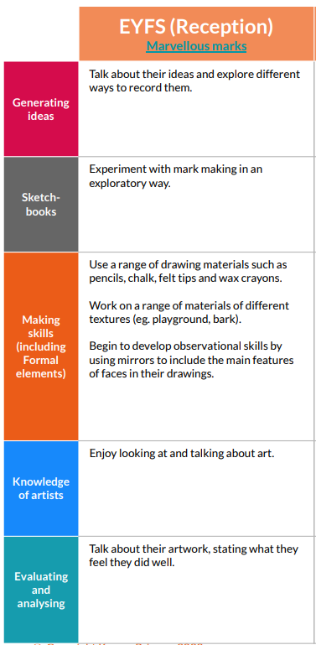 |  | - Painting and mixed media: Paint my World  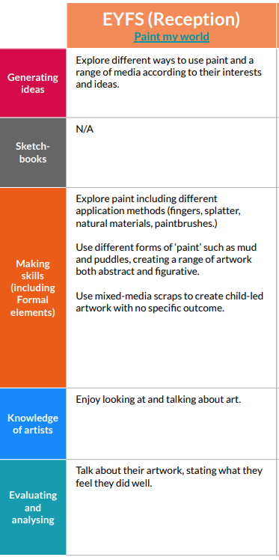 | - Sculpture and 3D: Creation Station  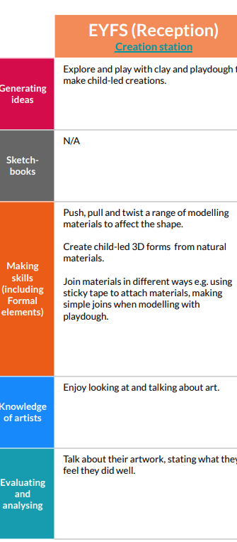 | - Craft and Design: Let’s Get Crafty  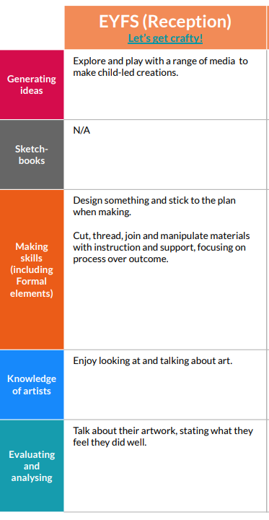 |  |  | - Seasonal Crafts
KAPOW Music Unit | - Celebration Music |  | - Exploring Sound | - Music and Movement | - Musical Stories |  |  | - Big Band

KAPOW Music Skills Covered  Across the year | Listening | Composing | Performing | Inter-related Dimensions of Music
 | - *Responding to music through movement, altering movement to reflect the tempo, dynamics or pitch of the music.  - Exploring lyrics by suggesting appropriate actions.  - Exploring the story behind the lyrics or music.  - Listening to and following a beat using body percussion and instruments. *Considering whether a piece of music has a fast, moderate or slow tempo.  - Listening to sounds and matching them to the object or instrument.  - *Listening to sounds and identifying high and low pitch.  - Listening to and repeating a simple rhythm.  - Listening to and repeating simple lyrics.  - Understanding that different instruments make different sounds and grouping them accordingly. | - Playing untuned percussion ‘in time’ with a piece of music.  - Selecting classroom objects to use as instruments.  - Experimenting with body percussion and vocal sounds to respond to music.  - Selecting appropriate instruments to represent action and mood.  - Experimenting with playing instruments in different ways | - Using their voices to join in with well-known songs from memory.  - Remembering and maintaining their role within a group performance.  - Moving to music with instruction to perform actions.  - Participating in performances to a small audience.  - Stopping and starting playing at the right time. | Pitch - To understand that what ‘high’ and ‘low’ notes are.  Duration - To recognise that different sounds can be long or short.  Dynamics -To understand that instruments can be played loudly or softly  Tempo -To recognise music that is ‘fast’ or ‘slow’. To understand that we can match our body movements to the speed (tempo) or pulse (beat) of music  Timbre - To know that different instruments can sound like a particular character.  Texture - To know that music often has more than one instrument being played at a time.  Structure - To recognise the chorus in a familiar song.  Notation - To know that signals can tell us when to start or stop playing
KAPOW Design and Technology Unit | - Junk Modelling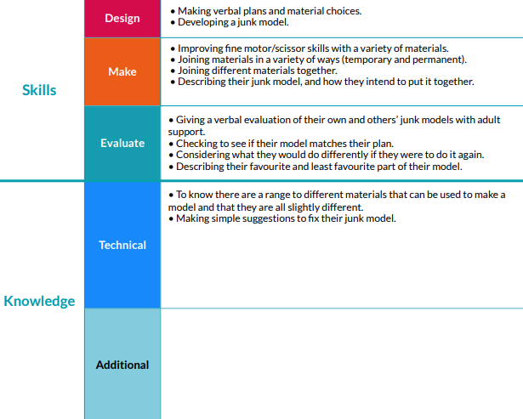 | - Cooking and Nutrition: Soup  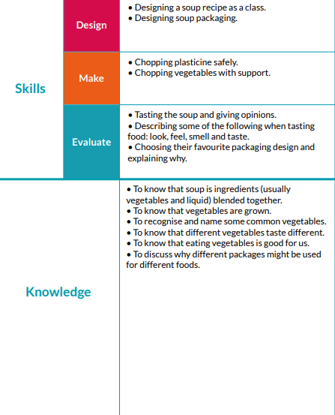 | - Textiles: Book Marks  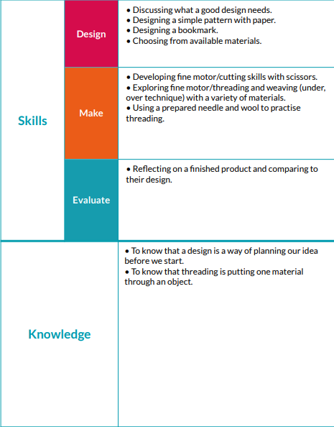 | Structures: Boats

