Supporting your child with reading at home

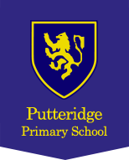

Introduction
At Putteridge Primary School, we recognise how important it is for us to work together to give your child the best support with reading. Reading at home is one of the easiest but most important ways in which you can help your child. As you share books, you are helping improve your child’s reading skills and also showing how enjoyable reading is.
We have a range of books to support your child’s reading within the school. The colour bands match the children’s phonic level so that children have the opportunity to use these skills when reading. These books allow children to experience a range of authors and genres, including non-fiction and poetry.
At Putteridge, we want children to:
- Develop a love reading
- See reading as an enjoyable experience
- Know reading can help them find out new things
- Be confident and competent readers
- Develop the reading skills necessary to read a range of different text types
- Develop a lifelong love of books
The support from you is essential for the school to be able to achieve this. Spending just 5-10 minutes a day can make a real difference to your child when they are learning to read.

Hearing your child read:
- Choose a quiet time and give your child your full attention.
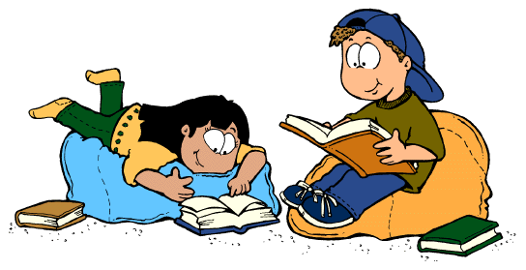
- Distractions such as the TV can make it difficult for your child to concentrate.
- Give your child time to investigate the book independently before reading it together.
- Read the title and ask them to tell you about the story.
- It is important, especially in Foundation Stage, that your child is given the opportunity to read aloud to an adult as often as possible.

- Reading aloud helps to improve decoding and listening skills.

- Help your child to sound out and blend any unfamiliar words.

- If they are still unsure, then tell them the word and explain the meaning.

- Use lots of praise!
What to do if your child is stuck:
- Pause and let your child have a try.

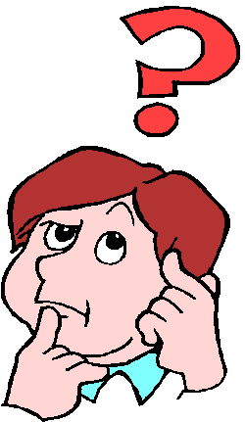
- Prompt to use phonics first. What sound does the word begin with? Can you say the sounds in the word? Blend them together, e.g. s/t/ar - star, m/i/l/k – milk, t/r/ai/n – train
- Read to the end of the sentence. What would make sense?
- What is the text about – what might fit here?
- Does it sound right?
- Look at the picture. Does it help?
- Praise them for having a try.
- These pictures might also give some support.

Talking about books:
- Do you like this book; why?
- Who is your favourite character?
- Tell me about a character in the book.
- Which words tell you what the character is like?
- How would you feel?
- What do you think will happen next?
- What would you do?
- What have you learned about …… in your book?
- What can you tell me about…?
- Did you enjoy the book? Why/why not?
- Which part did you like the best?
Understanding (Comprehension):
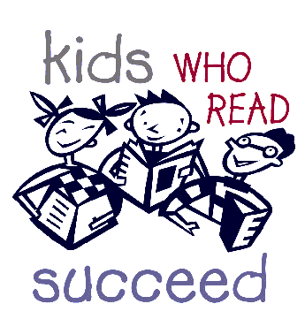
- Responding to questions by finding information that is in the text.
- Being able to answer questions where the information is not on the page by looking for clues.
- Thinking about situations and predicting what might happen.
- Putting yourself in a character’s shoes and understanding what is going on from their viewpoint.
- Book talk to make your child think.
Reading to your children:
    - Introduce your children to different types of books; classic fiction, chapter books, short stories, joke books, poetry, non-fiction.

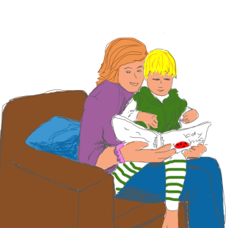
    - Read them the book that was your favourite when you were a child.

    - Read slowly, with expression. Try to use different and funny voices for characters.

    - Follow the words and read the story using the pictures.

    - Talk about what is happening and what might happen next. Leave the story on a cliffhanger!
Top Tips for Reading at Home:
- Keep sessions short
- Keep sessions relaxed – find a comfortable place where you and your child can settle down
- Give lots of praise. Progress may not always be fast – children do not always find the skill of reading and understanding easy to grasp
- Talk about the book before you begin to read – look at the front cover, and the pictures (if any) and ask your child to think about or even guess what the book may be about.
- Ask questions to check your child’s understanding e.g. What might happen next? Why did something happen?
- Talk about the book afterwards – did your child enjoy it? Why? What was the best bit?
- If your child struggles over a particular word, try to find ways to help them remember it e.g. by looking at the ‘shape’ of the word, or by guessing the word from the meaning of the sentence.
- Don’t give up on the bedtime story, even if your child is a good reader. The more stories and books your child hears, the more they will want to read.
- Be a good model for your children – let them see you reading – anything and everything – newspapers, magazines, catalogues, books etc. – let them know that reading is a valuable skill.
- Telling them about a book or story you liked when you were a child. You may still be able to find a copy of it on the internet!
- Making up a story or telling them about when you were a child or something that happened to you at school, remember you don’t always need a book to tell a good story.
- Taking it in turns to read parts of the story.
- Telling them one thing you really enjoy about listening to them read.

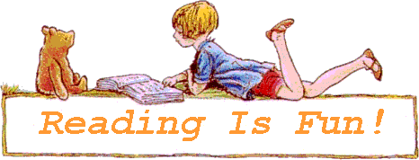

Book bands
Lilac

Pink

Red

Yellow

Blue

Green

Orange

Turquoise

Purple

Gold

White

Lime

Copper

Topaz

Ruby

Emerald

Dark Blue

Free Reader

Reception

Year One

Year Two

Key Stage Two
Foundation Stage Reading
Reading Lilac books
Wordless picture books encourage young children to tell their own stories. Sharing wordless books is a great way to build important literacy skills, including listening skills, vocabulary, comprehension — and an increased awareness of how stories are “built,” as the storyteller often uses a beginning, middle, end format. For a book with no words, you’ll be surprised at all the talking you will do, and all the fun you’ll have!

How to support your child with Lilac level books:
Your child is beginning to discover the excitement of books. Although these books have no words, they are an important introduction to reading.
Please encourage your child to:
- Look at the pages in order, and talk about what is happening on the left-hand page before the right-hand page.
- Talk about what is happening on each page, rather than just talking about what they see in each picture.
- Tell you who or what the book is about.
- Model story telling together using the pictures before if they are hesitant to begin with.

Reading Pink books
Pink level is the very first level of reading books which has words. The books have short, simple, highly predictable text involving familiar objects and actions. The sentence structures include decodable words, high frequency words and the illustrations provide full support for the text.

How to support your child with pink level books:
- Read the words carefully. Ask your child to sound out and blend only the words they can’t read yet, not every word. Eventually almost all words will become part of your child’s ‘sight memory’, and they won’t have to sound out at all.
- On second and third readings of the book, encourage them to read with more pace and with less focus on sounding out the letters in each word.
- Make a story out of a whole book, rather than focusing just on what is happening on each page.
- Tell you about something that happened in the book, or about something they found out in the book.

Reading Red books
These books consolidate learning from previous levels. Red level books have a slightly increased number of words, number of pages and slightly more complex story lines.

How to support your child with red level books:
- Read the words carefully. Most of the words can be recognised or sounded out. Ask your child to sound out and blend only the words they can’t read yet, not every word. Eventually almost all words will become part of your child’s ‘sight memory’, and they won’t have to sound out at all.
- On second and third readings of the book, encourage them to read with more pace and with less focus on sounding out the letters in each word.
- Make a story out of a whole book, rather than focusing just on what is happening on each page.
- Tell you about something that happened in the book, or about something they found out in the book.

Reading Yellow books
Yellow band books offer more varied sentence structure and natural language. Fiction features more variation in pattern with more new words. Non-fiction uses personal experiences and simple non-fiction tools such as diagrams, labels and captions.

Year One Reading

The children in Year 1 have a guided reading session in class every day. Across the week, the children will complete a range of reading-based activities, including reading with a teacher, a phonics-based activity and an independent comprehension task that is matched to their current reading level. The children will also be listened to on a 1:1 basis each week.

At several points across the year, the children will be assessed for their reading fluency, pace and understanding to see if they are ready to move onto the next colour band.

The books that the children take home are carefully matched to their current phonics knowledge and the children should be able to read these aloud independently or with the support of an adult. In order to check their understanding of what they are reading, you can ask them a range of questions such as:

Retrieval questions:
When/where is this story set?
Who is/are the main character(s)?
Which is your favourite/worst/funniest/scariest part of the story?

Sequencing questions:
What happens in the beginning of the story?
What happened at the end of …?
What happened before that?
Can you retell the story in 20 words or less?

Vocabulary questions:
Can you find a word/sentence that tells/shows you that…?
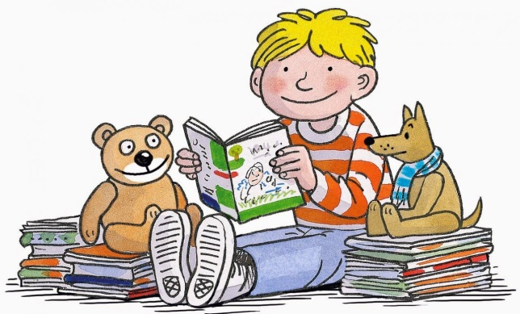
Why do you think the author used the word…to describe…?
Can you find a word that means the same as…?

Prediction questions:
Where do you think… will go next?
What do you think… will say/do next?
What do you think this book will be about? Why?
Inference questions:
What do you think… means? Why do you think that?
Why do you think...?
When do you think....?
Where do you think...?
How do you think…?

Year Two Reading
The children in Year 2 have a guided reading session in class every day. During this time, the children will independently access a text from their current reading colour band. They respond to a range of questions to show that they can understand what they are reading at this level.

The children will also be heard read at several points throughout the year to assess their fluency, pace when reading and understanding to see if they are ready to move up to the next colour band.

The books the children come home with give the children an opportunity to read aloud to a grown up and your support with this is very much appreciated. As well as listening to your child read, you can check that they understand the meaning of unfamiliar words and ask them questions to check their understanding of what they are reading.

Try to choose one question from each section below:

Vocabulary Questions:
Can you find a noun/adjective/verb that tells/shows you that..?
Why do you think that the author used the word… to describe…?
Which other word on this page means the same as…?
Find an adjective in the text which describes…

Retrieval Questions:
Ask a range of ‘who, what, where, when, why, how’ questions, e.g.
Who is/are the main character(s)?
When/where is this story set? How do you know?
Which is your favourite/worst/funniest/scariest part of the story? Why?
Tell me three facts you have learned from the text.
What did… look like/do?
Where in the book would you find…?
Find the part where…

Sequencing Questions:
What happens in the story’s opening?
How/where does the story start?
What is the problem in this story? How is it resolved?
Can you retell the story to me in 20 words or less?

Inference Questions:
What do you think… means? Why do you think that?
Why do you think…?
How do you think…?
When do you think…?
Where do you think…?
How has the author made us think that…?

Prediction Questions
Where do you think… will go next?
What do you think… will say/do next?
What do you think this book will be about? Why?
How do you think that this will end? What makes you say that?

Year Three Reading
The children in Year 3 have a guided reading session in class every day. During these sessions, the children will independently access a text with questions linked to this. They will respond to a range of questions with a focus on understanding what they have read, and the language used.

Some children will have additional reading sessions focussing on a book at the same level as their current reading colour band, with targeted questions to deepen their understanding and reading aloud to improve fluency and pace of reading.

All children will be heard read at several points throughout the year to assess their fluency, pace when reading and understanding to see if they are ready to move up to the next colour band.

The books the children come home with give the children an opportunity to read aloud to a grown up and your support with this is very much appreciated. In Year 3, some children are able to be more independent with their reading and may be able to read to themselves and then discuss their book with an adult (please check with your child’s teacher to see if they are ready to do this). Whilst listening to your child read is extremely important, in Year 3 we promote lots of discussion about the text and questioning to check your child has understood what is happening in the book. We explore the language used and explore the text for clues to help us understand character motives, feelings and to predict what might happen next.

Try to choose one question from each section below:

Vocabulary Questions:
What does this word/phrase/sentence tell you about the character/setting/feelings?
Can you find a word that means the same as…?
What other words/phrases could the author have used here?
How has the author made you feel by writing...?

Inference Questions:
What do you think.... means? Why do you think that?
What clues tell us that…?
Why do you think...?
How do you think....?
Can you explain why....?
What do these words mean and why do you think that the author has chosen them?

Retrieval Questions:
Who are the characters in this text?
When / where is this story set? How do you know?
Which part of the story best describes the setting?
When did the character…?

Prediction Questions:
What do you think is happening here? What might this mean?
Can you think of another story with a similar theme?
Which stories have openings like this? Do you think that this story will develop the same way?
Why did … do that?
What was … thinking when …. happened? How do you know?
How did the characters choice affect what happened next? What could they have done differently?

Summarising Questions:
What is the main point in this paragraph?
Sum up what has happened so far in X words or less.
Which is the most important point in these paragraphs?

Compare, Contrast and Comment:
What is similar/different about two characters?
Explain why... did that.
Describe different characters’ reactions to the same event.
Is this as good as...?
Which is better and why?

Year Four Reading
The children in Year 4 have a guided reading session in class every day. During this time, the children will be taught targeted comprehension skills which focus on question types such as retrieval, prediction, deduction and inference. The children will have the opportunity to apply these skills to an independent text linked to their current reading level. The class will read a text pitched at an age-appropriate level with an aim to develop their vocabulary knowledge and to apply the taught skills. They will respond to a range of questions to show that they are able to read and understand a text at this level, sometimes supported by an adult.

The children will also be heard read at several points throughout the year to assess their fluency, pace when reading and understanding to see if they are ready to move up to the next colour band. The books the children come home with give the children an opportunity to read aloud to an adult and your support with this is very much appreciated. As well as listening to your child read, you can check that they understand the meaning of unfamiliar words and ask them questions to check their understanding of what they have read.

Try to choose one question from each section below:

Vocabulary Questions:
What does this part tell you about the character/setting/ mood?
Find a word which means the same as…?
How has the author made you feel by writing...? Why?
Can you find a word tells/shows you that..?
Why do you think that the author used the word… to describe…?
Find a word in the text which describes…

Retrieval Questions:
Find the... in this text. Is it anywhere else?
When/where is this story set? How do you know?
Find the part of the story that best describes the setting.
What do you think is happening here? Why?
What might this mean?
When/where is this story set? How do you know?
Which is your favourite/worst/funniest/scariest part of the story? Why?
Where in the book would you find…?
Find the part where…

Sequencing Questions:
What happens in the story’s opening?
How/where does the story start?
What is the problem in this story? How is it resolved?
Can you retell the story to me in 20 words or less?

Inference and Deduction Questions:
What do you think.... means? Why do you think that?
I think....; do you agree? Why / why not?
How do you think....feels? Why?
Can you explain why.... happened?
What do these words mean and why do you think that the author chose them?
Why is this an important character/ item in the story?

Prediction Questions:
What do you think with happen next?
How might the character react?
What would you do in this situation?
Why did the author choose this setting? Will that influence the story?
Can you think of another story with a similar theme? How are they the same/ different?

Year Five Reading
The children in Year 5 have a guided reading session in class every day. During these lessons, the children will independently access a text and answer targeted questions about what they have read. When reading the text, children are encouraged to discuss the vocabulary and word choices made by the authors and we often hold class discussions about what is happening in the text.

In Year 5, we encourage the children to read for pleasure and allow them to select the books they want to read. The children are able to borrow books from the range available in the classroom. Our reading challenge promotes different genres and encourages the children to select and read a wide variety of text types and genres.

The books that the children come home with give the children a great opportunity to share their reading selections and read aloud to an adult and your support with this is very much appreciated. During this time with your child, you can check their understanding of what they are reading, discuss the meaning of unfamiliar words, ask their opinions of the text and ask them questions about what they think will happen further on in the story or text.

Here are some examples of questions that you could ask:
Vocabulary Questions:
What does this word/phrase/sentence tell you about the character/setting/mood?
By writing..., what effect has the author created? Do you think they intended to?
What other words/phrases could the author have used here? Why?
How has the author made you/this character feel by writing...? Why?

Retrieval Questions:
Find the... in this text. Is it anywhere else?
When/where is this story set? Find evidence in the text.
Find the part of the story that best describes the setting.
What do you think is happening here? Why?
Who is telling this story? What makes you think that ?

Summarising Questions:
What is the main point in this paragraph? Is it mentioned anywhere else?
Sum up what has happened so far in… words/seconds or less.
Which is the most important point in these paragraphs? Why?
Do any sections/paragraphs deal with the same themes?

Inference Questions:
What do you think.... means? Why do you think that? Could it be anything else?
I think....; do you agree? Why/why not?
Why do you think the author decided to...?
Can you explain why....?
What do these words mean and why do you think that the author chose them?

Prediction Questions:
Can you think of another story with a similar theme? How do their plots differ?
Which stories have openings like this? Do you think that this story will develop the same way?
Why did the author choose this setting? Will that influence the story?

Compare, Contrast and Comment Questions:
What is similar/different about two characters? Did the author intend that?
Explain why... did that.
Describe different characters’ reactions to the same event.
Does this story have a moral?
Which is better and why?

Year Six Reading
The children in Year 6 participate in a daily guided reading session involving a range of different genres. To begin with, we look at the tricky language that will appear in the text and the children will complete a vocabulary activity that provides them with the opportunity to understand the meaning of unfamiliar words and broaden their own knowledge. The children then read a text that has been carefully selected to match their age and interest of and they will then answer a range of questions in a variety of ways. The children are encouraged to refer to the text and provide evidence to support their responses. Some children will be doing this in a guided group with adult support.
To further encourage a love of reading, we run a Page Turners competition where children are asked to read a range of different books over the half term, in order to broaden their reading horizons with prizes as a reward for doing so. In Year 6, children have the opportunity to choose their own books to read and these can be selected from the wide choice in the classroom, from the library or home. The children are at times directed with their choices, to ensure that the books provide the relevant challenge. We ask that children read a minimum of five times per week and where possible, we ask for an adult to listen to them read and ask questions. Some children are also listened to by an adult in school.
Here are some of the types of question you can ask you child when they are reading to you:

Vocabulary Questions:
What does this word/phrase/sentence tell you about the character/setting/mood?
By writing..., what effect has the author created? Do you think they intended to?
What other words/phrases could the author have used here? Why?
How has the author made you/ this character feel by writing...? Why?

Retrieval Questions:
Find the... in this text. Is it anywhere else?
When/where is this story set? Find evidence in the text.
Find the part of the story that best describes the setting.
What do you think is happening here? Why?
Who is telling this story? What evidence tells you this?

Summarising Questions:
What is the main point in this paragraph? Is it mentioned anywhere else?
Sum up what has happened so far in… words/seconds or less.
Which is the most important point in these paragraphs? Why?
Do any sections/paragraphs deal with the same themes?

Inference and Deduction Questions:
What do you think.... means? Why do you think that? Could it be anything else?
I think....; do you agree? Why/why not?
Why do you think the author decided to...?
Can you explain why....?
What do these words mean and why do you think that the author chose them?

Prediction Questions:
Can you think of another story with a similar theme? How do their plots differ?
Which stories have openings like this? Do you think that this story will develop the same way?
Why did the author choose this setting? Will that influence the story?

Compare, Contrast and Comment Questions:
What is similar/different about two characters? Did the author intend that?
Explain why... did that.
Describe different characters’ reactions to the same event.
Does this story have a moral?
Which... is better and why?

High Frequency Words
High frequency words are common words, words that appear very often in written texts. They are a mixture of decodable words (words that can be sounded out) and tricky/exception words (words in which the English spelling code works in an unusual or uncommon way, which means the words have to be learned and recognised by sight).
First 100 high Frequency words
By Year One, the following words appear most frequently in the books your child will read. As your child learns these, it is helpful if they practise reading and spelling these on a regular basis.
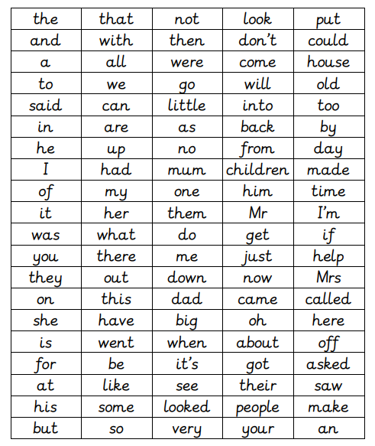

Next 200 high frequency words
By the end of Year Two, the number of high frequency words your child will read has increased to also include these words:
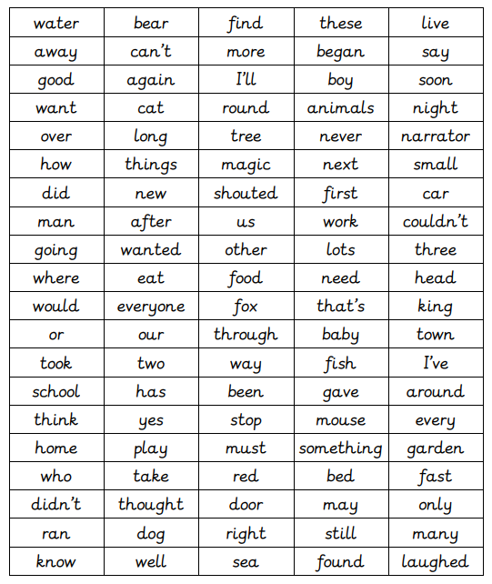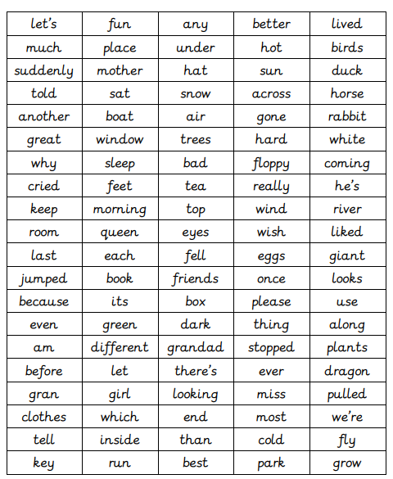
Rewards
In Key Stage 1, we develop a love of reading through reading bugs. The children collect different reading bugs for every twenty books that they read.
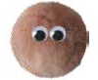 Bronze – 20 books |  Silver – 40 books
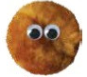 Gold – 60 books | 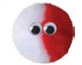 Platinum – 80 books
 Diamond – 100 books |  Super – 120 books
 Amazing – 140 books |  Outstanding -160 books
 Ultimate – 180+ books

In Lower Key Stage 2 (Years 3 & 4), we move towards encouraging pupils to read more regularly. All children are expected to read at home at least three times per week. If a child reads five times or more in a week they receive a tick towards a reading badge. A badge is earned for five ticks received (they have read 5 times or more across five separate weeks), 10 ticks and then 15, 20, 30 and 40 weeks.
As we move in to Upper Key Stage 2, children in Year 5 are encouraged to read a variety of genres by completing a stamp card with 5 different genres each half term. If children succeed in reading at least 5 books (1 per genre), they receive a bookworm badge. In Year 5, the colours are black, grey, white, red, orange and yellow.
In Year 6, children continue to be encouraged to read a diverse range of books and to expand the volume of their reading. Completed books are given a points value (1 point per 100 pages). Children aim to get 10 points per half term - to help them achieve this, some genres (chosen by the class teacher) are worth a bonus point.
In Year 6, children continue from the badge level they achieved in Year 5 and progress on to light green, dark green, light blue, mid blue, dark blue and purple.
Useful websites
https://home.oxfordowl.co.uk/reading/reading-at-home/
https://www.booktrust.org.uk/books-and-reading/tips-and-advice/reading-tips/
https://www.bbc.co.uk/bitesize/articles/zbxby9q

If you have any questions, then please contact the class teacher through your child’s yellow diary.

